**Querying Data by Using Q&A**

**Demonstration Steps**

Ask a Question by Using Q&A

1. In Power BI Desktop, on the **Home** ribbon, click **Publish**.
2. If you are prompted to save your changes, click **Save**.
3. The report will then be published to the Power BI portal. When the window displays Success, click **Open 'Adventure Works Sales.pbix'** **in Power BI** to view the report online.
4. When the browser opens, click **Sign in**, enter your email address and password, click **Sign in**, and then wait for the report to open in Internet Explorer.
5. When the report is visible, click **Pin Live Page**.
6. In the **Pin to dashboard** dialog box, click **New dashboard**, type **Adventure Works Sales** in the box, and then click **Pin live**. If the Introducing Featured dashboard message appears, click **Got it**.
7. Expand **My Workspace**, under **Dashboards**, click **Adventure Works Sales**.
8. Click in the **Ask a question about your data** box, and then point out the list of tables and fields that automatically appears.
9. Type **sales person**. Q&A returns a list of suggestions. Select **sales person > city** and the table is reordered.

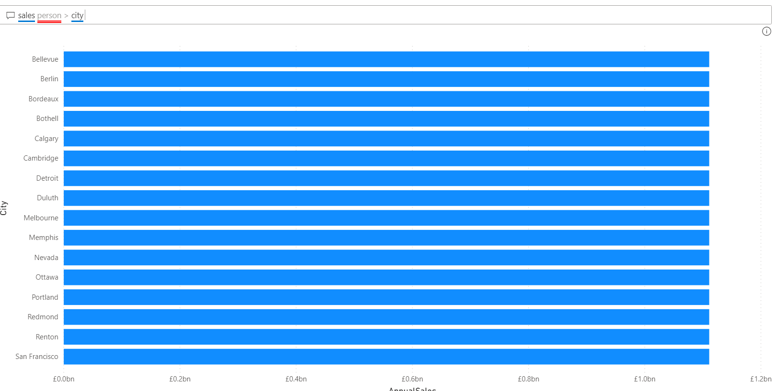

1. In the Q&A box, type **show company name and unit price as pie chart**. When the chart is visible, in the top-right of the report, click **Pin visual**.

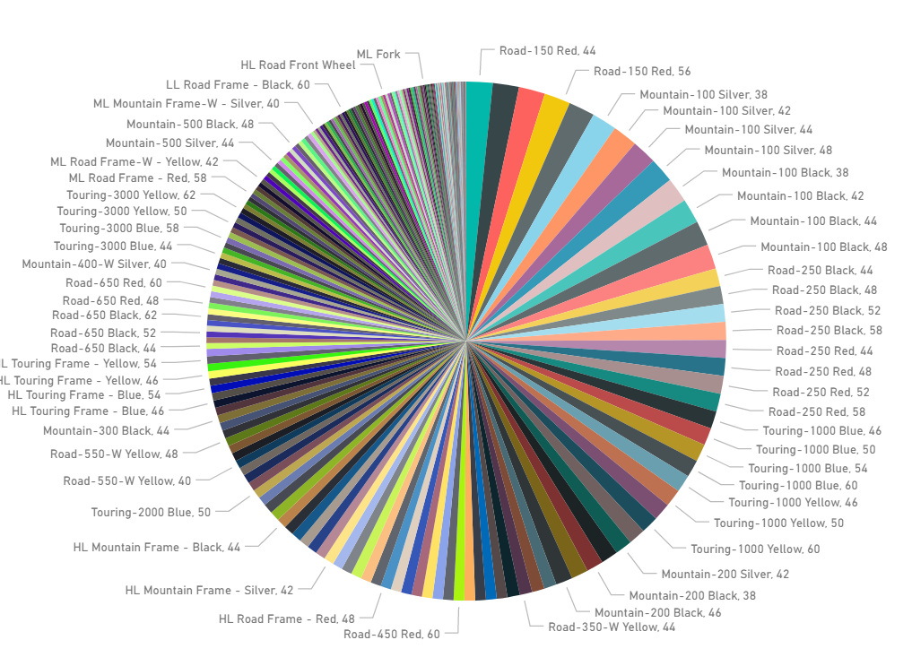

1. In the **Pin to dashboard** dialog box, leave **Existing dashboard** selected, and then click **Pin**.
2. Click **unit price** to highlight it, and then scroll down the list of suggestions in the Q&A box, to show how Q&A is picking up the columns from the dataset to create suggestions.
3. Under **My Workspace**, under **Dashboards**, click **Adventure Works Sales**. Scroll down the dashboard if necessary, to display the new charts on the dashboard.
4. Close Internet Explorer.
5. In Power BI Desktop, in the Publishing to Power BI window, click **Got it**, and then close Power BI Desktop.